Only handwritten solutions are accepted. The exam is closed book and closed notes. Write legibly with a pencil only (0.7 mm - 0.9 mm is preferred). Carry the given System of Units and show the full details of your solution with correct formulas. No credit is provided for answers without supporting equations. If you suspect a typo or have a serious question, please notify me. All required tables and formulas are attached, and you may separate them for your convenience. Answer all questions on this exam paper only. Additional paper will be provided if required. Solution on self-provided paper is NOT accepted. Only non-programmable calculators may be used. I hold No responsibility for defective calculator or for any missing pages of your exam. No other electronic device of any kind such as a headset, cellphone, tablet, and laptop computer will be allowed during the test. Any student found in possession of the aforementioned device(s) will immediately be removed from the exam and receive a grade of zero. Please be sure to turn in all exam problems regardless of what you did! You must not seek any help from anyone!
Time limit is 150 minutes.

HONOR PLEDGE

I, NAME (print): _________________________________________________hereby, state that the solution was obtained by me, and I did not seek or receive any help from other students. Neither did I provide help to anyone else and maintain the University of South Carolina’s Honor Code.

Please sign _________________ Starting 12:30 PM. Ending 3:00 PM.

Tuesday, December 06, 2022
Question 1. (15 points)
- Defining entropy and irreversibility in a system, explain how can you change entropy of a substance going through a reversible process?

- Explain how water's entropy can decrease when it freezes without violating the second law of thermodynamics. Specifically, explain what happens to the entropy of its surroundings.
Water can reduce its own entropy via expelling its entropy to the surroundings, resulting in an increase in heat.

Question 2. (15 points)
A reversible heat pump cycle operates at steady state between hot and cold reservoirs at TH = 300 ºK and TC = 285 ºK, respectively. The rate of heat transfer at the high temperature is 5 kW.
- a. Determine the net power input, in kW.
$$W=\frac{Q_{H}\left(T_{H}-T_{C}\right)}{T_{H}} →\frac{5\left(300-285\right)}{300}=0.25kW$$

- b. Determine the heat transfer rate from the cold reservoir at TC, in kW.
$$W=Q_{H}-Q_{C}→Q_{C}=5-0.25=4.75 kW$$

- c. Determine the coefficient of performance of the cycle.
Coefficient of Performance: $β=\frac{T_{H}}{T_{H}-T_{c}}=\frac{300}{300-285}=20$

Question 3. (25 Points)
An industrial heater operating at steady state has two inlets and one exit. At inlet 1, water vapor enters at p₁=10 bar, T₁ = 320 ⁰C with a mass flow rate of 65 kg/s. At inlet 2, liquid water at p₂ = 10 bar, T₂ = 70 ⁰C enters through an area A₂ = 40 cm². Saturated liquid at 10 bar exits at port 3 with a volumetric flow rate of 0.095 m³/s.
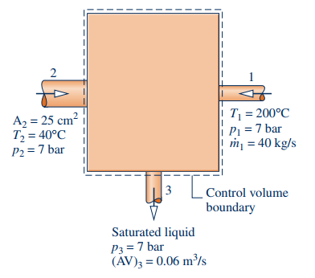
INDUSTRIALHEATER
A₂=40 cm²
T₂=70 ⁰C
P2=10 bar
$\dot{m}$₂ =? kg/s

P₁=10 bar
T₁=320 ⁰C
$\dot{m}$₁=65 kg/s

Saturated Liquid
P₃=10 bar
(AV)₃ = 0.095 m³/s
$\dot{m}$₃=? kg/s

- What is the mass flow rate in kg/s at exit 3? Show the proper equations to support your answer (No credit just for answer).
$$From Table A-3, υ_{f}=1.1273*{10}^{-3}$$
$${\dot{m}}_{3}=\frac{AV}{υ}=\frac{0.095}{1.1273*{10}^{-3}}=84.27 kg/s$$

- What is the mass flow rate at inlet 2 in kg/s? Show the proper equations to support your answer (No credit just for answer).
$${\dot{m}}_{2}={\dot{m}}_{3}-{\dot{m}}_{1}=84.27-65=19.27 kg/s$$

- What is the velocity V₂ at inlet 2 in m/s? Show the proper equations to support your answer (No credit just for answer).
$$From Table A-2, υ_{f}=1.0228*{10}^{-3}$$
$$V=\frac{{\dot{m}}_{2}υ}{A}=\frac{19.27*1.0228*{10}^{-3}}{(0.004)}=4.92734 m/s$$

- What is the enthalpy in kJ/kg at inlet 1?
$$From Table A-4, h=3093.9 kJ/kg$$

- What is the specific volume in m³/kg in inlet 1?
$$From Table A-4, υ=0.2678 m^{3}/kg$$

Question 4. (20 points)
Refrigerant 134a enters a horizontal pipe operating at steady state at 70 ⁰C, 0.6 MPa, and a velocity of 50 m/s. At the exit, the temperature is 80 ⁰C and the pressure is 0.32 MPa. The pipe diameter is 0.05 m. Show full details of your calculation. Determine:
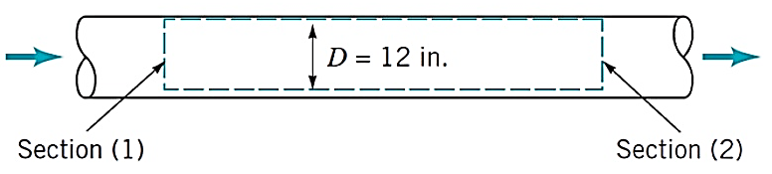
0.05 m

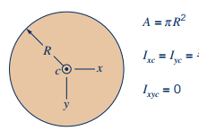
0.05 m

T₂ = 80 ⁰C
P₂ = 0.32 MPa
V₂ =?
T₁ = 70 ⁰C
P₁ = 0.6 MPa
V₁ = 50 m/s
m₁=?

- The mass flow rate of the refrigerant 134 a, in kg/s ?
$$From Table A-12, υ=0.04304 m^{3}/kg$$
$$\dot{m}=\frac{AV}{υ}=\frac{50*π*{\left(\frac{0.05}{2}\right)}^{2}}{0.04304}=2.281 kg/s$$

- The velocity at the exit, in m/s ?
$$From Table A-12, υ=0.08674 m^{3}/kg$$
$$V=\frac{\dot{m}υ}{A}=\frac{0.08674*2.281}{π*{\left(\frac{0.05}{2}\right)}^{2}}=100.766 m/s$$

Question 5. (25 points)
A turbine operating at steady state receives air at a pressure of P1 = 3.0 bar and a temperature of T1 = 390 K. Air exits the turbine at a pressure of P2 = 1.0 bar. The work developed is measured as 74 kJ per kg of air flowing through the turbine. The turbine operates adiabatically, and changes in kinetic and potential energy between inlet and exit can be neglected.
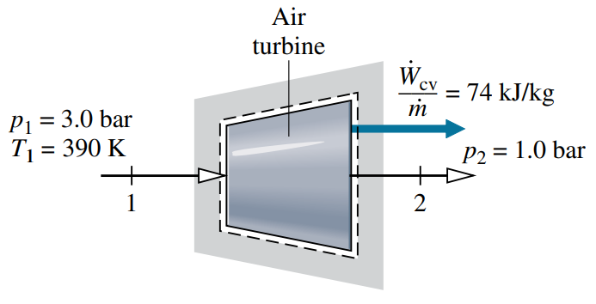

- Sketch the T – s diagram (demonstrating actual expansion and isentropic expansion between state 1 and 2).
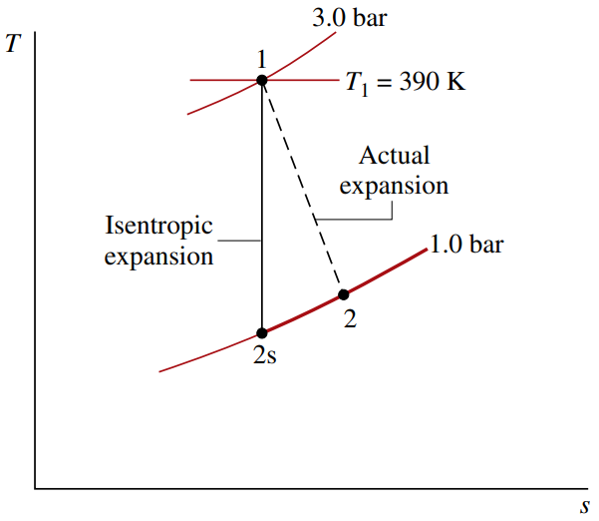
- Determine the isentropic turbine efficiency.
From Table A-22, $P_{r}\left(T_{1}\right)=3.481$, and thusly$, P_{r}\left(T_{2s}\right)=\left(\frac{P_{2}}{P_{1}}\right)*P_{r}\left(T_{1}\right)=\frac{1}{3}*3.481=1.1603$
Interpolating $h_{2s}$ from Table A-22 with $P_{r}$, $h_{2s}=285.27$
$${\left(\frac{{\dot{W}}_{cv}}{\dot{m}}\right)}_{s}=h_{1}-h_{2s}=390.88-285.27=105.6\frac{kJ}{kg}$$
$$η_{t}=\frac{{{\dot{W}}_{cv}}/{\dot{m}}}{{\left({{\dot{W}}_{cv}}/{\dot{m}}\right)}_{s}}=\frac{74}{105.6}=0.7=70\%$$

- (7)-Steam enters a turbine with a pressure of 60 bar, a temperature of 540 ⁰C, and a velocity of 150 m/s. Saturated vapor at 120 ⁰C exits with a velocity of 90 m/s. At steady state, the turbine develops work equal to 620 kJ per kg of steam flowing through the turbine. Heat transfer between the turbine and its surroundings occurs at an average outer surface temperature of 25 ⁰C. Neglect the change in potential energy between inlet and exit. Show the following steps in your calculations (watch the units!):
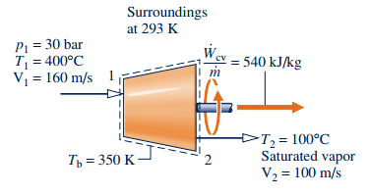
at 20 ⁰C
P₁ = 60 bar
T₁ = 540 ⁰C
V₁ = 150 m/s
620 kJ/kg

T₂ = 120 ⁰C
Saturated Vapor
V₂ = 90 m/s
T_{b} = 25 ⁰C

- (4)-Determine the heat transfer rate, required for the process.
$$\frac{{\dot{Q}}_{cv}}{\dot{m}}=\frac{{\dot{W}}_{cv}}{\dot{m}}+\left(h_{2}-h_{1}\right)+\frac{\left(V_{2}^{2}-V_{1}^{2}\right)}{2}$$
$$⇒620\frac{kJ}{kg}+\left(2706.3{kJ}/{kg}-3517{kJ}/{kg}\right)+\left(\frac{{90}^{2}-{150}^{2}}{2}\right)*\frac{1}{1000}$$
$$⇒-197.9 kJ/kg$$

- (3)-Determine the entropy production per unit mass flowing through the turbine.
$$\frac{{\dot{σ}}_{cv}}{\dot{m}}=s_{2}-s_{1}-\frac{{\dot{Q}}_{cv}}{\dot{m}}*\frac{1}{T_{b}}$$
$$⇒7.1296-6.9999-\left(-\frac{197.9}{298.15}\right)$$
$$⇒0.793\frac{kJ}{kg⋅K}$$

